Artykuł:
“Public safety considerations constraint the conservation of large old trees and their crucial ecological heritage in urban green spaces”
Arkadiusz Fröhlich, Fabian Przepióra, Szymon Drobniak, Grzegorz Mikusiński, Michał Ciach

Science of The Total Environment, Volume 948, 2024, 174919,
ISSN 0048-9697,
https://doi.org/10.1016/j.scitotenv.2024.174919.
(https://www.sciencedirect.com/science/article/pii/S0048969724050691)

Abstract: Large old trees in urban public green spaces deliver a diversity of values essential for human well-being, including biodiversity conservation. Yet, the conservation of large old trees bearing key wildlife microhabitats interferes with safety considerations. This intuitive notion, however, is backed by an insufficient and scattered body of evidence. Here, we empirically examined this process using data on 5974 trees across 510 sample plots, organized as quintuplets within 102 sample sites, including urban parks, cemeteries, recreational forests, and historic reserves in the urban agglomeration of Kraków, Poland. Our analyses demonstrate that trees situated in areas frequently visited by people, or those near walking paths, benches, or playgrounds, have elevated accident hazards and, therefore, necessitate intensive tree surgeries (pruning and logging) to remain harmless. Large old trees, which bear the most diverse microhabitats and pose greater risks when they collapse, are especially affected by these measures. Accordingly, we found that the co-occurrence of large trees with elevated accident hazards results in significant losses of dead and sloped trees, and trees with cavities, injuries, crown deadwood, fungal fruiting bodies, or epiphytes, particularly in parks and, to a lesser extent, in recreational forests. Apparently, some tree-related microhabitats, such as injuries, cavities, and microsoils, also emerge in risky spots after pruning. Our findings underscore that the conservation of large old trees and their ecological functions faces significant challenges due to safety considerations. To address conservation challenges and harmonize human coexistence with biodiversity, we recommend enhancing environmental awareness and reevaluating arboricultural and planning policies. This would involve establishing strategic and pocket reserves on city peripheries and interiors, allowing larger older trees to thrive and develop important microhabitats without compromising public safety. Otherwise, we risk losing many large old trees and/or their superior value for wildlife, which will regenerate over decades, if not centuries.

Keywords: tree-related microhabitats; TreMs; habitat trees; evidence-based conservation; urban ecology; urban forestry; urban planning

PL: Stare drzewa i ludzie

Stare, duże drzewa, głęboko zakorzenione w naszej kulturze i religii, rozwijają się przez stulecia, aby dostarczać wielu usług ekosystemowych, takich jak cień, a także niezbędnych mikrosiedlisk – np. dziupli, szczelin, martwych gałęzi, owocników grzybów i roślin epifitycznych – niezbędnych dla przyrody, od mikroorganizmów po ptaki i ssaki. Nowe badania Arkadiusza Frӧhlich (IOP PAN) i współpracowników ujawniają, że te sędziwe drzewa zanikają i tracą swoje funkcje ekologiczne z powodu powszechnych praktyk zarządzania miejską zielenią. Gdy znajdują się w pobliżu ścieżek spacerowych, ławek lub placów zabaw, gdzie najczęściej przebywają ludzie, drzewa te często podlegają obfitemu przycinaniu lub całkowitemu usuwaniu, aby zapewnić bezpieczeństwo ludzi. Aby budować zrównoważoną przyszłość i harmonizować relacje człowieka z naturą, niezbędne jest zwiększenie świadomości ekologicznej i przemyślenie naszej obecnej polityki „pielęgnacji” zieleni. Obiecującym rozwiązaniem może być tworzenie rezerwatów strategicznych na obrzeżach miast lub 'rezerwatów kieszonkowych' w centrach miejskich, aby chronić te stare drzewa, które często pamiętają czasy królów, a nie będą się w stanie odnowić w perspektywie naszego i przyszłego pokolenia.

Link do artykułu: https://doi.org/10.1016/j.scitotenv.2024.174919

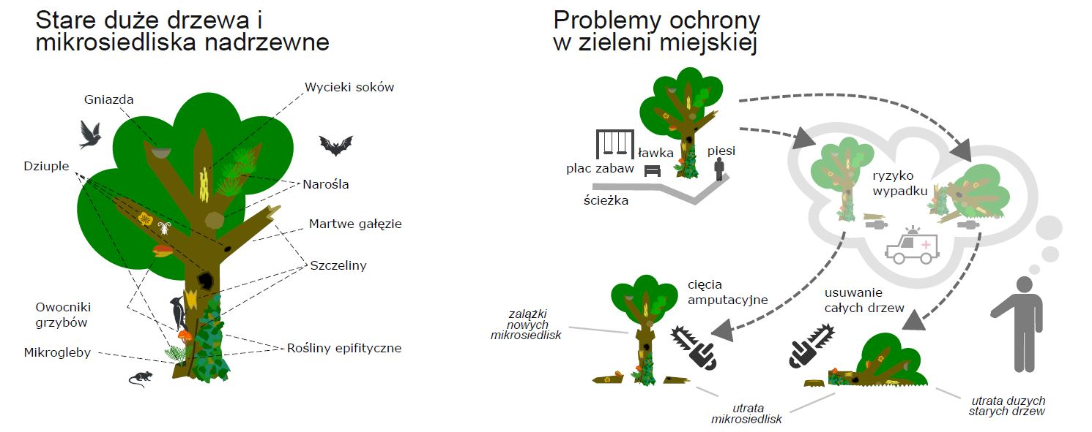

EN: Old trees & people

Large old trees, deeply rooted in our culture and religion, take centuries to develop to provide a variety of ecosystem services, such as shading, along with essential microhabitats—including cavities, crevices, crown deadwood, fungal conks, and epiphytic plants—that support a wide range of wildlife, from microbes to birds and mammals. However, a new study by Arkadiusz Frohlich (institute of Nature Conservation, Polish Academy of Sciences) reveals that these ancient trees are disappearing and losing their ecological functions due to common urban management practices. When located near walking paths, benches, or playgrounds, where people are more frequent, these trees often undergo significant pruning or removal to ensure public safety. To foster a sustainable future and harmonize humans with nature, it is crucial to raise environmental awareness and rethink our arboriculture policies. A promising approach might involve creating strategic reserves on city peripheries or establishing "pocket reserves" within city interiors to preserve these large old trees, which have often stood since the Middle Ages and are non-renewable within our lifetimes.

Link to article: https://doi.org/10.1016/j.scitotenv.2024.174919

